**BA/DA TRAINING**

**TRIGGER AND QUERIES - Assignment – 11(July19,2019)**

**SHAFALI GUPTA**

1. **EXPLAIN TRIGGER AND QUERIES.**

**Ans:- Trigger –**

A trigger is a stored procedure in database, which automatically invokes whenever a special event in the database occurs. For example, a trigger invoked when a row inserted into a specified table or when certain table columns being updated.

Given Student Report Database, in which student marks assessment recorded. In such schema, create a trigger so that the total and average of specified marks automatically inserted whenever a record is insert.

Here, as trigger will invoke before record is inserted so, BEFORE Tag can be used.

Suppose the database Schema –

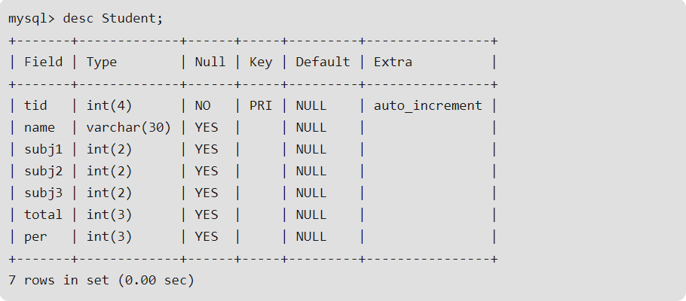

SQL Trigger to problem statement.

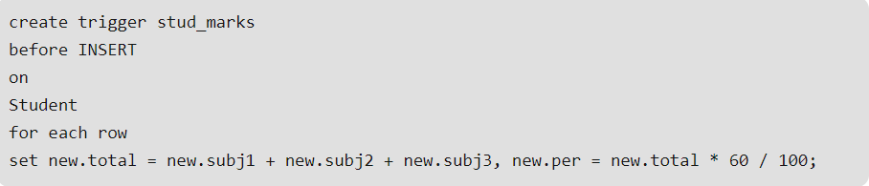

Above SQL, statement will create a trigger in the student database in which whenever subject’s marks are entered, before inserting this data into the database, trigger will compute those two values and insert with the entered values. i.e.

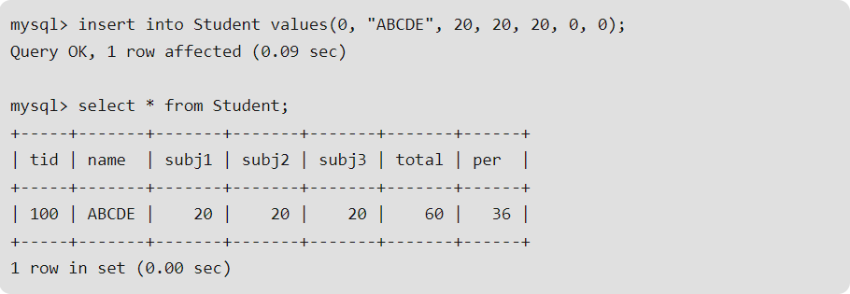

**Queries** - Queries are the syntactical statements when executes on a database retrieve the results. Queries used to retrieve the column and rows of a given table, or to update/Alter the data in a table or to delete the columns or rows of the table.

Queries used to retrieve the data from multiple tables based on different functions. Below are the few examples of queries.

SELECT:



UPDATE:

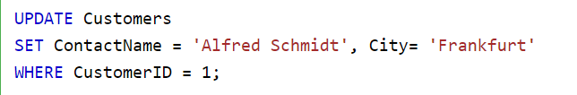

DELETE:

